Division operator : [How to understand `u=r÷s`, the division operator, in relational algebra? - Stack Overflow](https://stackoverflow.com/questions/34978533/how-to-understand-u-r%C3%B7s-the-division-operator-in-relational-algebra)

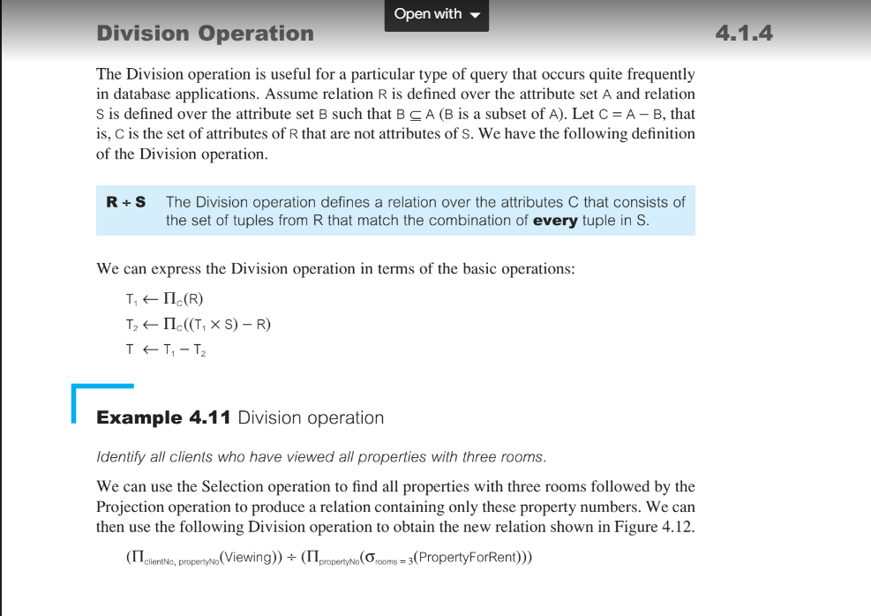

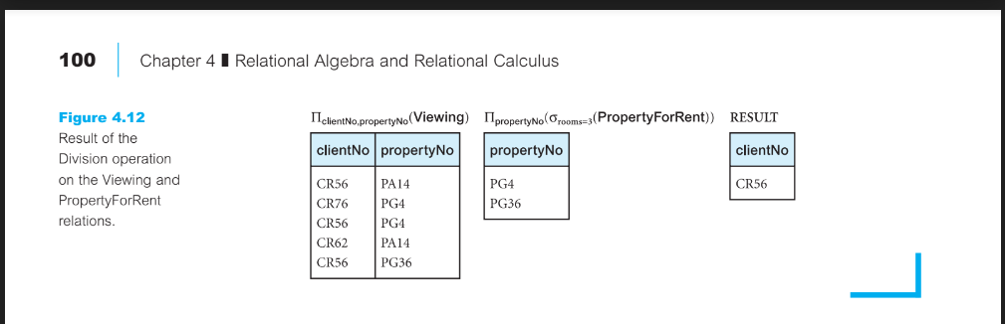

Too tough: [Databases: GATE CSE 2009 | Question: 45 (gateoverflow.in)](https://gateoverflow.in/1331/gate-cse-2009-question-45)

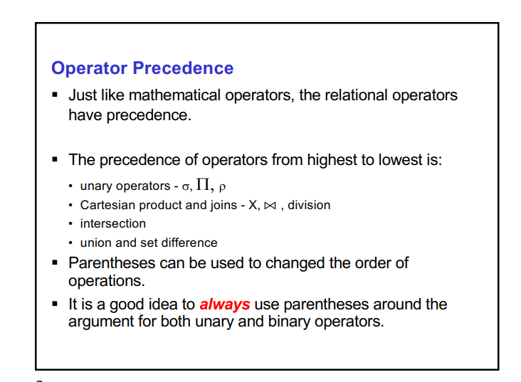

[sql - maximum and minimum number of tuples in natural join - Stack Overflow](https://stackoverflow.com/questions/22673235/maximum-and-minimum-number-of-tuples-in-natural-join)

[Databases: Number of tuples in natural join (gateoverflow.in)](https://gateoverflow.in/77822/number-of-tuples-in-natural-join)